**Project SQL**

1. Display the last name and salary of employees earning more than $12,000

**SELECT last_name**

**,salary**

**FROM employees**

**WHERE salary > 12000**

1. Display the last name and department number for employee number 176

**SELECT last_name**

**,department_id**

**FROM employees**

**WHERE employee_id = 176**

1. Display the last name and salary for all employees whose salary is not in the range of $5,000 to $12,000

a)

**SELECT last_name**

**,salary**

**FROM employees**

**WHERE salary < 5000**

**OR salary > 12000**

b)

**SELECT last_name**

**,salary**

**FROM employees**

**WHERE salary NOT BETWEEN 5000**

**AND 12000**

1. Display the last name, job ID, and start date (hire date) for the employees with the last names of Matos and Taylor.Order the query in ascending order by start date.

**SELECT last_name**

**,job_id**

**,hire_date**

**FROM employees**

**WHERE last_name = 'Matos'**

**OR last_name = 'Taylor'**

**ORDER BY hire_date ASC**

1. Display the last name and department number of all employees in departments 20 or 50 in ascending alphabetical order by name.

a)

**SELECT last_name**

**,department_id**

**FROM employees**

**WHERE department_id = 20**

**OR department_id = 50**

**ORDER BY first_name ASC**

b)

**SELECT last_name**

**,department_id**

**FROM employees**

**WHERE department_id IN (**

**20**

**,50**

**)**

**ORDER BY first_name ASC**

1. Display the last name and job title of all employees who do not have a manager.

**SELECT last_name**

**,job_id**

**FROM employees**

**WHERE manager_id IS NULL**

1. Display the last name, salary, and commission for all employees who earn commissions. Sort data in descending.

**SELECT last_name**

**,salary**

**,commission_pct**

**FROM employees**

**WHERE commission_pct IS NOT NULL**

**ORDER BY hire_date DESC**

1. Find the highest, lowest, sum, and average salary of all employees. Label the columns Maximum, Minimum, Sum, and Average, respectively.

**SELECT MAX(salary) AS Maximum**

**,MIN(salary) AS Minimum**

**,SUM(salary) AS Sum**

**,AVG(salary) AS Average**

**FROM employees**

1. Display details of jobs where the minimum salary is greater than 10000.

**SELECT \***

**FROM jobs**

**WHERE min_salary > 12000**

1. Display the first name and join date of the employees who joined between 2002 and 2005.

**SELECT first_name**

**,hire_date**

**FROM employees**

**WHERE hire_date BETWEEN '2002'**

**AND '2005'**

1. Display first name and join date of the employees who is either IT Programmer or Sales Man.

**SELECT first_name**

**,hire_date**

**FROM employees**

**WHERE job_id = 'IT_PROG'**

**OR job_id = 'SA_MAN'**

1. Display employees who joined after 1st January 2008.

**SELECT \***

**FROM employees**

**WHERE hire_date > '2008-01-01'**

1. Display details of employee with ID 150 or 160.

**SELECT \***

**FROM employees**

**WHERE employee_id = 150**

**OR employee_id = 160**

1. Display first name, salary, commission pct, and hire date for employees with salary less than 10000.

**SELECT first_name**

**,salary**

**,commission_pct**

**,hire_date**

**FROM employees**

**WHERE salary < 10000**

1. Display job Title, the difference between minimum and maximum salaries for jobs with max salary in the range 10000 to 20000.

**SELECT job_title**

**,DIFFERENCE('min_salary', 'max_salary') AS difference**

**FROM jobs**

**WHERE max_salary BETWEEN 10000**

**AND 20000**

1. Display first name, salary, and round the salary to thousands.

**SELECT first_name**

**,salary**

**,ROUND(salary, - 3) AS 'round_salary'**

**FROM employees**

1. Display details of jobs in the descending order of the title.

**SELECT \***

**FROM jobs**

**ORDER BY job_title DESC**

1. Display employees where the first name or last name starts with S.

**SELECT \***

**FROM employees**

**WHERE last_name LIKE 'S%'**

**OR last_name LIKE 'S%'**

1. Display employees who joined in the month of May.

**SELECT \***

**FROM employees**

**WHERE month(hire_date) = 05**

1. Display details of the employees where commission percentage is null and salary in the range 5000 to 10000 and department is 30.

**SELECT \***

**FROM employees**

**WHERE commission_pct = NULL**

**AND salary BETWEEN 5000**

**AND 10000**

**AND department_id = 30**

1. Display first name and date of first salary of the employees.

SELECT first_name, eomonth(hire_date)

1. FROM employees

24. Display first name and experience of the employees.

**SELECT first_name, DATEDIFF(day, hire_date, '08-05-2023') AS days_experience**

**FROM employees**

SELECT first_name, DATEDIFF(YEAR, hire_date, '08-05-2023') AS year_experience

FROM employees

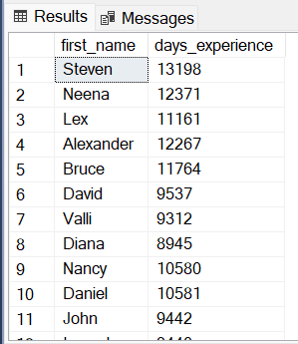

25. Display first name of employees who joined in 2000.

**SELECT first_name**

**FROM employees**

**WHERE year(hire_date) = 2000**

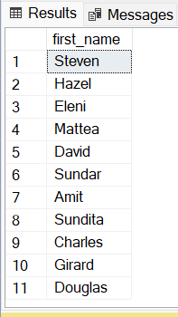

26. Display first name and last name after converting the first letter of each name to upper case and the rest to lower case.

**SELECT UPPER(LEFT(first_name, 1)) + LOWER(SUBSTRING(first_name, 2, len(first_name))) AS first_name**

**,UPPER(LEFT(first_name, 1)) + LOWER(SUBSTRING(last_name, 2, len(last_name))) AS last_name**

**FROM employees**

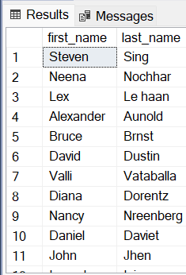

27. Display the first word in job title.

**SELECT SUBSTRING(job_title, 1, CHARINDEX(' ', job_title + ' ') - 1) AS first_word**

**FROM jobs**

SELECT SUBSTRING(job_title, 1, 1) AS first_word

FROM jobs

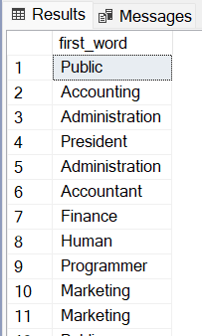

28. Display the length of first name for employees where last name contain character ‘b’ after 3rd position.

SELECT LEN(first_name), *

FROM employees where SUBSTRING(last_name, 4, 1) = 'b'

29. Display first name in upper case and email address in lower case for employees where the first name and email address are same irrespective of the case.

**SELECT upper(first_name)**

**,lower(email)**

**FROM employees**

30. Display employees who joined in the current year.

**SELECT \***

**FROM employees**

**WHERE year(hire_date) = year(current_timestamp)**

31. Display the number of days between system date and 1st January 2011.

32. Display how many employees joined in each month of the current year.

SELECT COUNT(EMPLOYEE_ID) as NumberOfEmployees , DATEPART(month, HIRE_DATE) as Month FROM EMPLOYEES

where DATEPART(year, HIRE_DATE) = 1998

group by DATEPART(month, HIRE_DATE)

select * from employees where DATEPART(YEAR, HIRE_DATE) = 1998

34. Display Employees Where The First Name Or Last Name Starts With S.

**SELECT \***

**FROM employees**

**WHERE first_name LIKE 'S%'**

**OR last_name LIKE 'S%'**

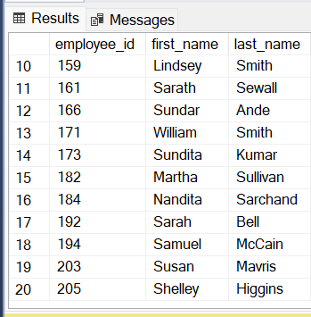

35. From The Employees Table Select The Last Name And The Job Id. Using The Case Statement, Give A Detailed Description To The Job Id. For Example: If Job Id Is ‘Ad_Vp’ Then Display ‘Administrative Vice President’, If The Job Id Is ‘Ad_Asst’ Then Display ‘Administrative Assistant’; Otherwise Display ‘Unknow Job Id’ (nie czyta as)

select last_name, job_id as 'Administrative Vice President' from employees where (job_id = 'AD_VP')

41. Display Manager Id And Number Of Employees Managed By The Manager.

**SELECT manager_id**

**,count(employee_id) AS 'number_of_employees'**

**FROM employees**

**WHERE manager_id IS NOT NULL**

**GROUP BY manager_id**

**ORDER BY COUNT(employee_id)**

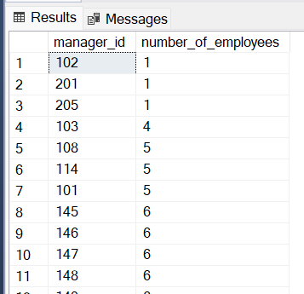

42. Display The Country Id And Number Of Cities We Have In The Country.

**SELECT country_id**

**,count(city) AS city**

**FROM locations**

**GROUP BY country_id**

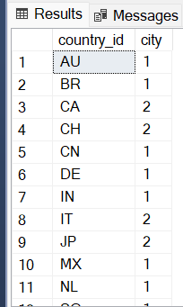

43. Display Average Salary Of Employees In Each Department Who Have Commission Percentage.

**SELECT department_id**

**,AVG(salary) AS average_salary**

**FROM employees**

**WHERE commission_pct IS NOT NULL**

**GROUP BY department_id**

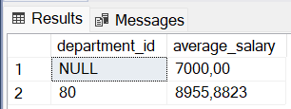

44. Display Job Id, Number Of Employees, Sum Of Salary, And Difference Between Highest Salary And Lowest Salary Of The Employees Of The Job.

Select Job_Id, Count (*), Sum(Salary), (Max(Salary)-Min(Salary)) As Difference From Employees

Group By Job_Id

45. Display Job Id For Jobs With Average Salary More Than 10000.

select job_id, AVG(salary) from employees group by job_id

having AVG(salary) > 10000

46. Display Departments In Which More Than Five Employees Have Commission Percentage.

select department_id, count(commission_pct) as employee from employees where commission_pct is not NULL group by department_id

having count(commission_pct) > 5

select department_id from employees where commission_pct is not NULL

47. Display Employee Id For Employees Who Did More Than One Job In The Past.

select employee_id, count(*) from job_history group by employee_id

having count(*) > 1

48. Change Salary Of Employee 115 To 8000 If The Existing Salary Is Less Than 6000.

**UPDATE employees**

**SET salary = 8000**

**WHERE employee_id = 116**

**AND salary < 6000**